Christopher Horyczun
October 3rd 2025
CS1450
Assignment 5 Design Notebook
Problem Solving:
For part One, we will be using Java’s built-in Stack class to push a set of values onto a stack. Count how many even numbers are in the stack without removing them. Then display all the values without altering the stack’s state.
For part two, we will create our own generic stack class with basic operations such as push, pop, peek, and isEmpty. Then read values from two files into two unsorted stacks, combine these stacks into one sorted stack with the smallest element on top, and separate any duplicate values into a different stack. The program must work with both integer and string data.
Understanding:
What I do Know | What I do not Know
- How to read a file  - A small understanding on push, pop, peek, and isEmpty | - How to fully use push, pop, peek, and isEmpty  - Where is start this assignment

Design Sketch:
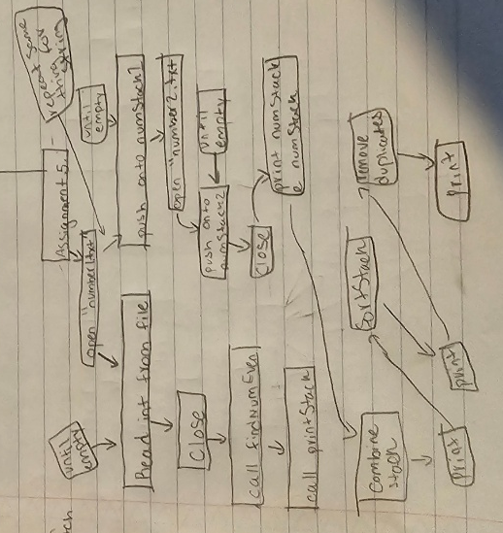
Pseudocode:
//Main
Create a JCF Stack<Integer> named stack
Open file "numbers1.txt"
While inside file
Read integer value
stack.push the value
Close "numbers1.txt"
Open file “numbers2.txt”
While inside file
Read integers vale
Stack.push the values
Close “numbers2.txt”
Int numEven to call findNumEven(stack)
Call printStack (stack)
SOP: “Number of even Values: “ numEven
Create GenericStack<Integer> numStack1
Open file “numbers1.txt”
While lines in file
Read int values
numStack1.push(values)
close “number1.txt”
////Repeat for numbers2.txt(numStack2)
Print numStack1 & numStack2 (using generic printStack)
Combine stacks
Print combine Stack (unsorted using generic printStack)
Sort combinedStack
Print sortedStacks (with duplicate using generic printStack)
Remove duplicate
Print sortedStack (with duplicate removed using generic printStack)
Print duplicates Stacks
////Repeat all of it for the Strings Sections

//Sort Stack
While unsortedStack is no empty
Pop the element from unsortedStack (put in temp)
While sortedStack is not empty and sortedStack.peep() (> temp)
Pop element from sortedStack
Push it back onto unsortedStack
Push temp onto sortedStack
Lesson Learned: I learned how to use generic stacks fully. How to combine 2 generic stacks together, and how to use push, peek, pop, isEmpty.

